SOCORRO STOREHOUSE
NEWSLETTER

JULY 2024

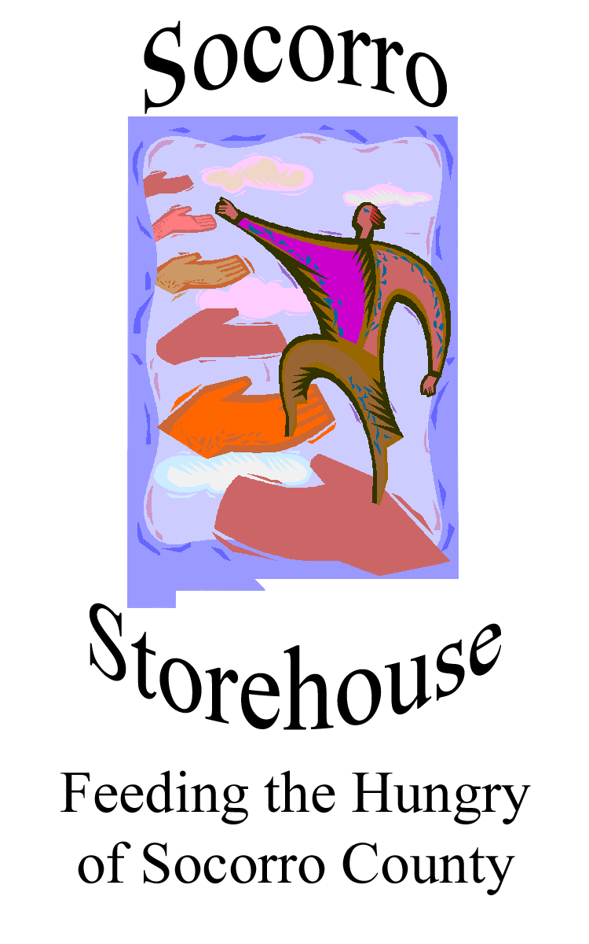

FOOD PANTRY NEWSLETTER

-Melissa Ramsey
Executive Director, Socorro Storehouse

What’s New at Storehouse
Made in Office 2007 for office2007.com
With the ending of state and federal COVID support for families in 2023, Storehouse has seen the weekly number of families increase from 20 to 30 in 2023 to 50 to 60 families in June 2024. Resources are strained and Storehouse is again asking the community for assistance.
El Defensor Chieftain article
Clients are enthusiastic about the addition of pet food to their monthly food boxes. Thanks to Animal Protective Association of Socorro (APAS) which donates large amounts of dog and cat food each month to Storehouse, this important grocery item is much requested and greatly appreciated.
Fundraising and Upcoming Events
This beautiful quilt, created and donated by the Socorro Fiber Arts Guild, is being raffled to support Storehouse. Tickets are available for $5 per raffle ticket or five tickets for $20. The raffle winner will be announced at the conclusion of the Festival of the Cranes in mid-December. You do not need be present to win. For tickets, contact
Our Annual Ice Cream Social is scheduled for September 7, Saturday, at Epiphany Episcopal Church. It’s a good time. Plan to
attend.
attend.
July 1, 2024
A Word From the Director

Volunteer/Donation Opportunities:
Many thanks to the following churches that monthly provide food and household cleaning products to Storehouse: St. Paul Methodist Church, Family Christian Center, and Epiphany Episcopal Church.

If you would like to volunteer to help at one of our events, or wish to donate food or funds please contact us at:
P.O. Box 701
Socorro, NM 87801
Email: socorrostorehouse@gmail.com, or call 575-835-2079
If you or someone you know needs help to supplement the food budget, please call the number above for more information.

