SOCORRO STOREHOUSE
NEWSLETTER

October 2024

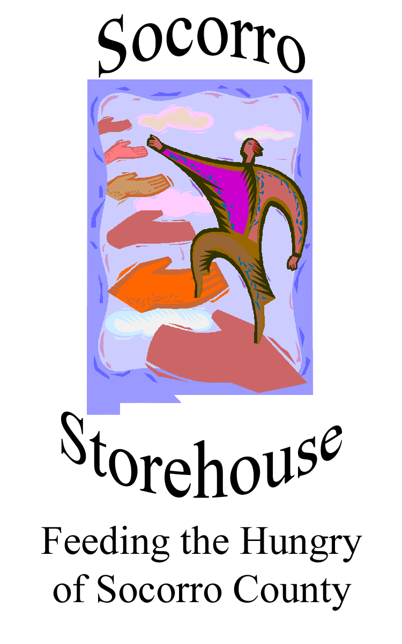

FOOD PANTRY NEWSLETTER

-Melissa Ramsey
Executive Director, Socorro Storehouse

What’s New at Storehouse
Made in Office 2007 for office2007.com
Food needs include the following:
Rice
Mac & cheese
Canned fruit in date
Canned meat in date

In the month of November, Storehouse will continue its Thanksgiving voucher program in cooperation with John Brooks SuperMart. Clients will be given vouchers which can be used to purchase food for their Thanksgiving meal. This program has proven to be very popular with clients, and Storehouse is delighted to be able to continue it.

In December Storehouse will close for two weeks from Christmas through New Years and into 2025.

Fundraising and Upcoming Events
The beautiful quilt pictured above, created and donated by the Socorro Fiber Arts Guild, is being raffled to support Storehouse. Tickets are available for $5 per raffle ticket or five tickets for $20. The winner will be announced at the conclusion of the Festival of the Cranes in mid-December. You do not need to be present to win. For tickets, contact Melissa at 575-835-2079.
OVERVIEW OF STOREHOUSE
The following is a reminder of what Storehouse is and how it operates in the community,
Socorro Storehouse is an emergency food pantry that has been serving the needs of underprivileged citizens of Socorro County since 2002. It is a Feeding America site and includes commodities

from The Emergency Food Assistance Program (TEFAP) administered by the U. S. Department of Agriculture.
Clients
Storehouse will work with anyone receiving food stamps (SNAP) or with a low income. Clients include families, children, the elderly, the homeless, the disabled, veterans, Hispanics, and Native Americans. At present, Storehouse has 200 registered families. Since the end of state and federal COVID monies in September 2023, Storehouse has experienced a steady increase in clients.
History
Storehouse began as a small food pantry at San Miguel Catholic Mission and today is the only emergency food pantry serving Socorro County. For 50 Thursdays out of the year Storehouse opens from noon to 2 p.m. to distribute boxes of groceries to its clients. The boxes average 30 to 35 lbs. and contain canned food, dry food, staples, baked goods, frozen meats, fruits, and vegetables, sometimes dairy and eggs, laundry soap, and sometimes pet food. Each week about 50 clients carry about 1,650 lbs. of food.
Sources of Food
- TEFAP food is delivered through Roadrunner Food Bank of Albuquerque.
- Wal-Mart donates food on a weekly basis.
- Storehouse purchases fresh produce from local grocery stores at retail prices.
- Local churches and farmers donate food items.
- Churches, civic organizations, schools, and college clubs conduct food drives and donate the food.

Sources of Funding
- Private and institutional donations
- Annual fund-raising events such as the Ice Cream Social and the Quilt Raffle
- Grants
Organization Structure
Storehouse is an independent 501(c)(3) corporation and is governed by a nine-member board of directors. Melissa Ramsey is the executive director of Storehouse. She is part-time and the only paid employee. Melissa supervises a team of 10+ volunteers who unload trucks, stock shelves, pack boxes, assist clients, do data entry, clean up, and make the place work.
In recent years Storehouse has implemented the following standing programs:
- The annual Thanksgiving voucher giveaways – this program allows clients to go to the local grocery store and buy their holiday meals.
- The fresh fruits and veggies program - through one of our first grants, we began to purchase fresh produce to add to the boxes.
- The homeless bag program – bags of special foods for the homeless (ready to eat and easy to open) are distributed weekly.
Storehouse also tries to respond to immediate community needs such as taking boxes of food to outlying rural areas at the beginning of the pandemic lockdown. Storehouse provided food to the firefighters in 2023 during a local wildfire event. We also partner with local organizations on community projects such as the Toby Jaramillo Memorial Christmas Food Drive, the Community Gardens, the New Mexico Tech Food Distribution, and the Socorro Senior Center Thanksgiving Dinner.
From humble beginnings to a larger organization that tries to meet the ever-increasing need of the community, Socorro Storehouse remains a lean operation that does a lot with a little.
Mission Statement
Socorro Storehouse serves the needs of Socorro residents by providing one box of food at a time.

Volunteer/Donation Opportunities:
Many thanks to the following churches that monthly provide food and household cleaning products to Storehouse: St. Paul Methodist Church, Family Christian Center, and Epiphany Episcopal Church.
If you would like to volunteer to help at one of our events, or wish to donate food or funds please contact us at:
P.O. Box 701
Socorro, NM 87801
Email: socorrostorehouse@gmail.com, or call 575-835-2079
If you or someone you know needs help to supplement the food budget, please call the number above for more information.

